Lancaster municipal gas


New Customer
Information Booklet

Pipeline Purpose & Calling 811
Natural gas is America’s most popular home heating fuel – heating more households than all other energy forms combined. In all, 52 percent of all heated U.S. households have natural gas heat.
Natural gas is increasingly popular for use by homeowners, schools, businesses, factories and electric power-generation plants because it is efficient, clean, reliable, and a relative bargain compared to alternative energy sources.
In our community, Lancaster Municipal Gas provides natural gas to more than 15,000 customers through a network of underground distribution lines. Main gas lines branch into household service lines. The pipes can be made of steel or plastic.
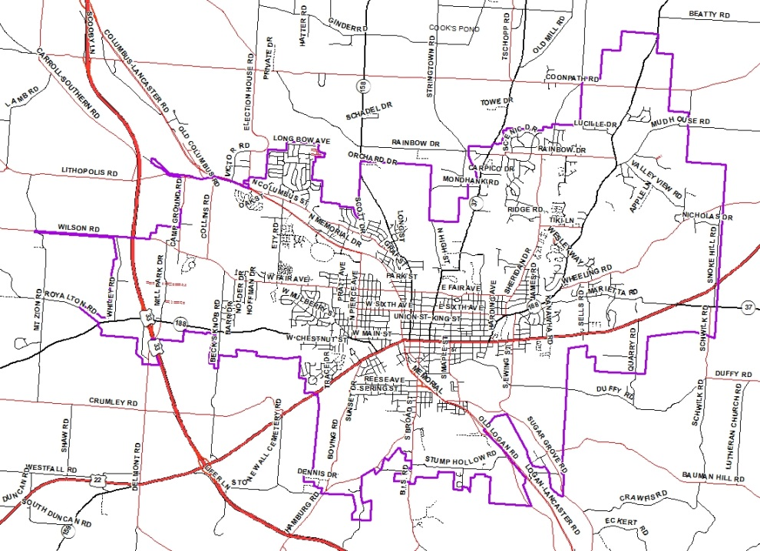

As an industry, steel pipes are being replaced with the more durable plastic piping. The main lines are typically 2 to 8 inches in diameter and are located roughly two-feet below the surface, while service lines are typically 1 to 1 1/4-inch in diameter and buried 12- to 18-inches below the surface.
That’s why it’s important before you move earth in any way to “Call Before You Dig”. Whether you’re installing an underground dog fence, planting a tree, or digging a post-hole, underground piping and other utilities can be damaged. By dialing “811” or calling the Ohio Utilities Protection Service (OUPS) directly at 1-800-362-2764, utility companies will be notified so that they can locate the lines on your property, you can then dig safely avoiding the hazards. For more information on the nationwide One Call System you can visit the website at www.call811.com. Calling before you dig can prevent a costly or even deadly mistake. 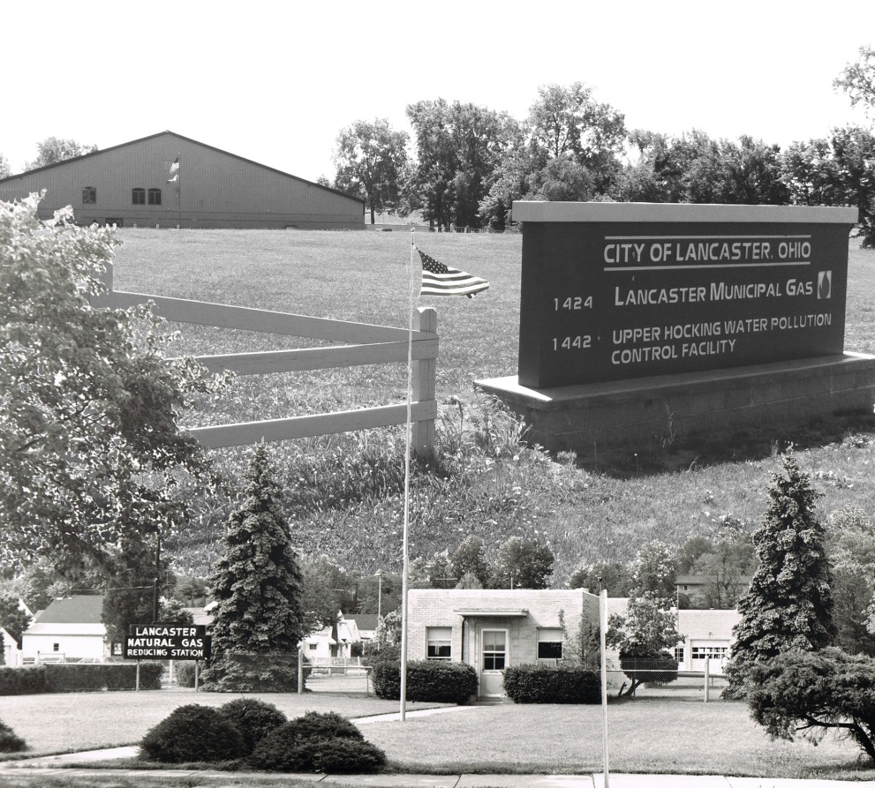

Two Full Working Days Before You Dig
Call



Or call OUPS
1-800-362-2764
It’s SMART. It’s FREE. It’s the LAW.

Leak Recognition & Response
Natural gas is a colorless, odorless gas; however, a chemical that smells like rotten eggs is added to help detect a possible leak. If you smell gas, or just think you might be smelling gas, leave the area immediately and call your local gas provider or call 911 from a neighboring home or business. Never turn switches on or off or use a flashlight or phone in the presence of the gas smell, because an electric spark could ignite the gas, causing an explosion.
Do your part to familiarize yourself and your family with these natural gas safety tips and continue to enjoy the value, comfort and benefits of America’s cleanest, most efficient energy source!
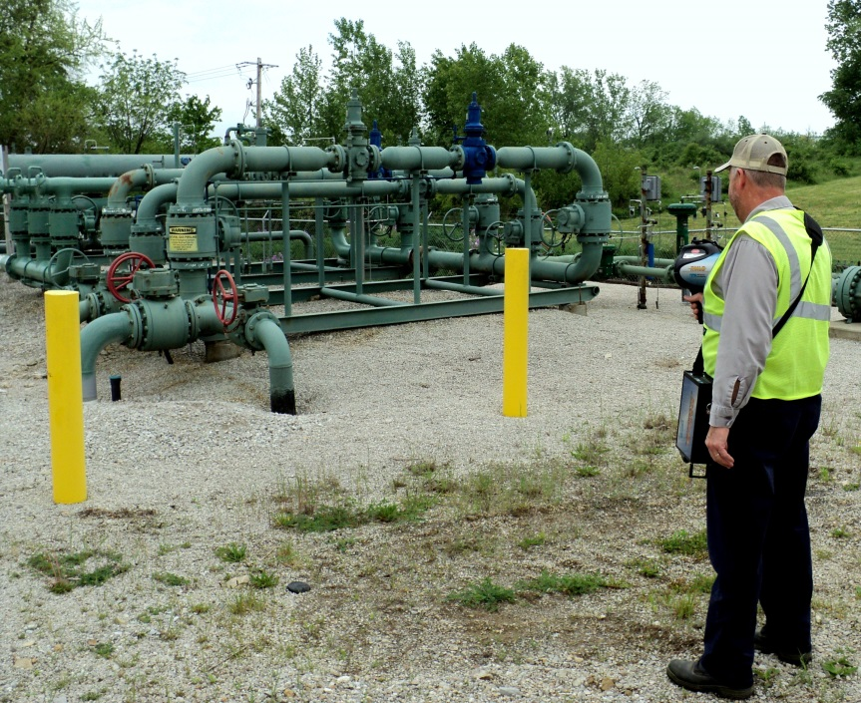
Hazardous Conditions Associated with Snow and Ice

Keep Vents and Equipment Clear
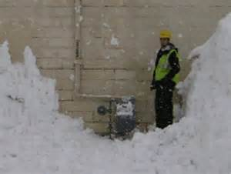
Meter Sets/Equipment
Excessive snow and ice buildup can potentially damage gas meters and regulators. This equipment should be kept clear of ice and snow by using a broom or other soft bristled device.
Vents for gas appliances must also be cleared following a major snow or ice storm to allow for proper venting and prevent carbon monoxide accumulation.
Sidewall vented appliances
Including; direct vent furnaces, fireplaces, tankless water heaters, etc.

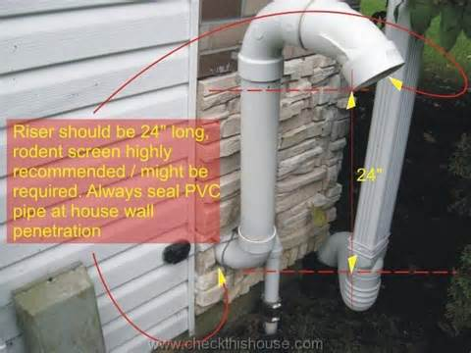
An outside vent terminal must not be obstructed. This can occur with snow and ice buildup as well as by vegetation and various other materials. When these vents get blocked poisonous carbon monoxide fumes may back up into the building causing a hazardous or often deadly condition.

For new sidewall vented appliances, manufacturer installation instructions must be followed and all state and local codes adhered to.

Carbon Monoxide Poisoning
When a gas appliance functions properly it produces Carbon Dioxide (CO²) and water vapor as natural byproducts of combustion; however, in certain situations where a defect in the appliance exists or an improper appliance installation is allowed, deadly carbon monoxide gas (CO) can be present.
Carbon monoxide is not always evident in the home because it is colorless odorless and tasteless. When a person experiences mild to moderate carbon monoxide sickness he or she usually feels excessively tired or nauseous at home but better when outdoors in fresh air. If multiple people in the same household experience flu-like symptoms while fuel burning appliances are used, it is recommended that a professional check the home for CO.

Carbon Monoxide Detectors
In addition to having a professional come into your home to check your appliances, you should have a carbon monoxide detector installed. Placement of this device should be close to areas you frequently occupy (such as, your bedroom and living room). The detector will keep a constant watch over the levels of CO in the home throughout the year. Batteries in this device should be checked in accordance with manufacturer’s instruction to ensure proper operation.
Symptoms of Carbon Monoxide Poisoning
Mild carbon monoxide poisoning can easily be confused with the flu, food poisoning or other illnesses; however, the long term effects of even mild poisoning can be very detrimental to health. That’s why it is better to recognize the symptoms as early as possible. Some of the symptoms include:

- Shortness of breath
- Mild nausea
- light headaches
Moderate levels of CO exposure can cause death when an individual is exposed for a long period of time. These symptoms include.
- Headaches
- Dizziness
- Nausea
- Light-headedness
High levels of CO can be fatal causing death within minutes. If the symptoms are not accompanied by fever, if everyone in the family is ill, or if the symptoms disappear when you leave the house, it could be CO poisoning.
What to do if you suspect CO poisoning.
If carbon monoxide poisoning is suspected, get affected persons into an area of fresh air immediately (preferably outside) and call 911.
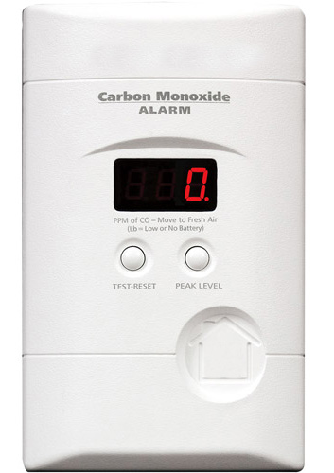

Maintain Your Buried Piping

Lancaster Municipal Gas (LMG) performs regular maintenance safety inspections on all facilities up to and including the outlet of the gas meter. If a problem exists on a customer owned portion of this line (from the curb valve to the meter), LMG will notify the customer of the issue and require the customer to correct the problem in a timely manner.

Piping past the meter is both owned and maintained by the homeowner, and LMG does not perform routine safety inspections on this pipe. The owner should be aware of the following:
- Buried piping that is not maintained may be subject to the potential hazards of corrosion and leakage.
- Buried piping should be:
  - Periodically inspected for leaks;
  - Periodically inspected for corrosion if the piping is metallic;
  - Repaired or removed from service if any unsafe condition is discovered.
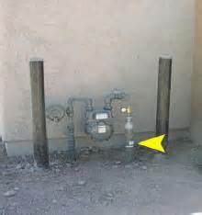
  - Before excavating/digging near buried piping, the piping should be located and excavating done carefully by hand. Underground locating contractors can assist with locating buried piping. A plumbing or heating contractor may be able to provide assistance with inspection and repair of buried piping.
For further guidance please contact Lancaster Municipal Gas at

(740) 687-6670

Space Heater Safety
Gas space heaters are a safe and reliable way to heat when used correctly, installed by a qualified professional, and maintained properly. The following are valuable safety tips regarding gas space heaters.
Have your gas heater and venting system installed by a professional and inspected in accordance with local codes.
Do not re-install a used space heater.
Keep flammable liquids and other combustible materials (boxes, newspapers, etc.) away from space heaters as well as other gas appliances.
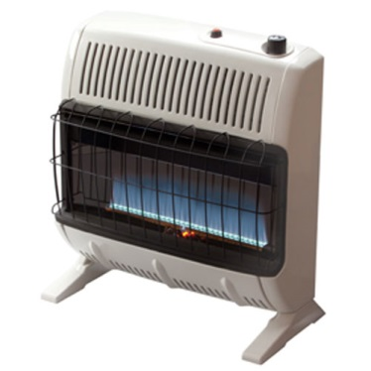

Excessively Hot Tap Water

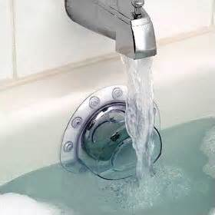

High water temperature can present a significant danger of scalding; especially to children and unsuspecting guests.
- Make sure your water heater is set to the manufacturers recommended temperature (or lower).
- Always check the water temperature before bathing children. Never leave a child unattended while bathing.

Check Your Appliance Connections

Interior Piping and Gas Appliance Connector Safety
Some gas flexible appliance connectors manufactured from 1970 to 1980 can fail over time and should be replaced. All connectors should be regularly inspected for damage and replaced when a potential issue is found. Please know:
- Only a qualified individual should inspect or replace the gas connector because some connectors are brittle and could fail with very little movement.
- When disconnecting gas appliances, gas connectors should be removed and the fuel line must be plugged and capped to prevent unintentional operation.
- Gas pipes should be properly maintained and never used for purposes like hanging clothes or supporting other structures.
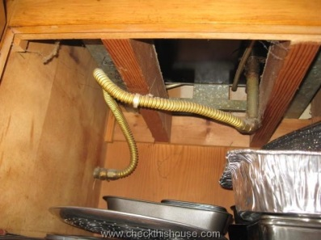

Corrugated Stainless Steel Tubing (CSST)
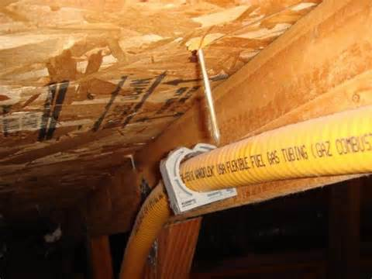

Corrugated Stainless Steel Tubing (CSST) is an International Fuel Gas Code approved piping for natural gas and is present in many homes today.
CSST is a flexible (usually yellow coated) stainless steel pipe usually found running through a home or business under floors, along sidewalls, and in an attic. CSST has many benefits over traditional black iron pipe installation because it much easier and usually less costly to install; however, pipe failure can be catastrophic if it is not installed properly.
If lighting strikes a building where CSST is installed, the current can travel along the piping wall and fail where the current exits the pipe because the pipe wall is generally much thinner than other types of natural gas piping. For this reason, CSST piping systems must be bonded to the electrical service grounding electrode system using no smaller than a 6 AWG copper wire or equivalent at the point where the piping enters the structure.
If CSST is present your home or business, Lancaster Municipal Gas recommends that you contact a licensed electrician to make sure it is properly bonded and grounded.
Lancaster Municipal Gas does not perform CSST bonding/grounding inspections.
If you are unsure whether your building contains CSST, contact a building inspector to arrange an inspection.

For Additional Information Contact:
Lancaster Municipal Gas
(740) 687-6670

Or

Visit Our Website @
www.ci.lancaster.oh.us/dept/gas/

